L0-D2 — K–M Model Specification
Version: 0.2 (Draft) Status: In Progress Last Updated: 05 June 2026

1. Purpose
The K–M Model Specification defines the dual-axis civilisational maturity model that underpins CivOS. It establishes:
- the K-axis (technological/energetic capacity)
- the M-axis (psychosocial/institutional maturity)
- the mathematical formulation of both
- the K–M mismatch as a structural risk indicator
- the implications for architecture, governance, and constraints
This deliverable ensures CivOS is grounded in a structured, falsifiable, non-ideological framework for understanding civilisational stability.

2. Scope
Included:
- Definitions of the K and M axes
- Mathematical expressions
- Thresholds and interpretation
- The Δ mismatch concept
- Epistemic limits and assumptions
- Implications for CivOS architecture
- Diagram references
Not included:
- Governance mechanisms (L0-D5)
- Architecture structure (L0-D1)
- Risk register detail (L0-D6)
- Implementation standards (L1)
- Operational processes (L2–L5)

3. Definitions & Concepts

3.1 Kardashev Scale (K-axis)
A logarithmic measure of a civilisation’s ability to harness and control energy.

3.2 Maslow-Derived Maturity Scale (M-axis)
A composite measure of psychosocial, institutional, and organisational maturity, based on:
- stability
- trust
- cooperation
- governance quality
- conflict resolution
- long-term planning
- shared reality
- psychosocial resilience

3.3 K–M Mismatch
The gap between a civilisation’s power (K) and its maturity (M). Large mismatches increase systemic risk.

3.4 Great Filter Interpretation
Civilisations fail when K rises faster than M. CivOS exists to raise M to keep pace with the increase in K.

3.5 Model Status and Epistemic Limits
The K–M model is a structured heuristic, not an empirically validated law. It is designed to:
- make civilisational risk legible
- provide a consistent conceptual framework
- support architectural reasoning
However:
- no civilisation has recorded K and M values across collapse events
- M cannot be directly measured as a single scalar
- Δ thresholds are provisional
- the model is subject to revision
This ensures the model is used appropriately and not over-interpreted.

4. Core Specification

4.1 Mathematical Definition of the K-Axis
$$K=\frac{{log⁡}_{10}(E)-6}{10}$$
Where:
- $E$= energy harnessed (in watts)
- 10⁶ W = baseline for K = 0
- 10¹⁶ W = planetary scale (K ≈ 1)
- 10²⁶ W = stellar scale (K ≈ 2)
Humanity’s current value:
$$K≈0.73$$

4.2 Mathematical Definition of the M-Axis
The M axis represents civilisational psychosocial maturity expressed as a normalised value in the interval $\left[0 , 1\right]$. It is constructed as a composite index derived from eight maturity dimensions, each scored on a standardised scale.
Let:
$$m_{i}∈[0,1]\text{for }i=1,…,8$$
The normalised maturity score for each dimension:
- Physiological Security & Basic Needs Reliability
- Safety, Stability & Rule-of-Law Integrity
- Social Cohesion & Trust Architecture
- Epistemic Health & Information Integrity
- Governance Capability & Institutional Competence
- Technological Alignment & Risk Stewardship
- Economic Resilience & Resource Stewardship
- Flourishing, Agency & Human Development
The overall maturity index M is defined as the arithmetic mean:
$$M=\frac{1}{8}\sum_{i=1}^{8}{m_{i}}$$
Each $m_{i}$is assessed using a qualitative rubric mapped onto $\left[0 , 1\right]$, reflecting the degree to which the civilisation demonstrates capability, reliability, foresight, and resilience in that domain.
Because the underlying dimensions are qualitative and judgement-based, the resulting value of M should be interpreted as a conceptual approximation, suitable for directional analysis and stability modelling, rather than as a precise empirical measurement.

4.2.1 Maturity Dimension Scoring Rubric
Each maturity dimension $m_{i}$is assessed using a qualitative scoring rubric mapped onto the interval $\left[0 , 1\right]$. Scores represent the civilisation’s demonstrated capability, reliability, and foresight within that domain.

Score | Descriptor | Definition
0.0 | Collapse | Systems absent or failing; maturity not present in this domain.
0.1–0.2 | Fragile | Highly unstable; provision unreliable; vulnerable to minor shocks.
0.3–0.4 | Developing | Basic structures present but inconsistent, uneven, or weakly integrated.
0.5 | Transitional | Mid-maturity; capable but variable; limited resilience to sustained stress.
0.6–0.7 | Competent | Generally reliable; able to manage moderate shocks; improving coherence.
0.8–0.9 | Advanced | High reliability, strong foresight, and effective long-term coordination.
1.0 | Fully Mature | Robust, resilient, self-correcting, and aligned with long-term wellbeing.
This rubric provides a standardised scoring method for all eight maturity dimensions and supports directional and comparative analysis within the K–M model.

4.2.2 System-Level Assessment and Regional Variation
Maturity scores reflect the behaviour of the global civilisation system, not a population-weighted or region-weighted average of local conditions. Regional variation is expected. Assessors should evaluate each dimension based on the civilisation’s system-level behaviour, including the degree to which local failures are contained or propagate globally.
“Dominant global pattern” refers to the behaviour of system-shaping regions and institutions—those whose actions, norms, or failures propagate through global networks and influence civilisation-level outcomes. Dominance is determined by systemic impact, not by population size, GDP, land area, or other demographic or economic weightings.
Local maturity differences are incorporated implicitly within the qualitative scoring process and do not require separate regional indices.

4.3 The K–M Mismatch
$$Δ=K-M$$
Δ is a directional indicator, not a precise measurement. It should be interpreted as:
- a relative comparison
- a risk signal
- a heuristic guide for architectural decisions
Humanity’s current mismatch:
$$Δ≈0.23$$
This places humanity in the indicative risk region, not a mathematically proven one.

4.4 Implications for CivOS
CivOS exists to:
- raise M as well as K
- stabilise Δ (the mismatch)
- ensure governance scales with capability
- reduce systemic fragility
This justifies CivOS principles such as:
- governance clarity
- anti-capture
- shared reality
- observability
- constraint-first design
- modularity
- replaceability

4.5 Thresholds and Interpretation
Region | Δ Value | Interpretation
Stable | Δ ≤ 0.1 | Indicative alignment between capability and maturity
Tension | 0.1 < Δ ≤ 0.2 | Early signs of strain; requires monitoring
Risk Zone | 0.2 < Δ ≤ 0.4 | Maturity may be insufficient; intervention advisable
Unstable | 0.4 < Δ ≤ 0.6 | High likelihood of systemic stress
Critical | Δ > 0.6 | Severe imbalance; collapse risk elevated
These thresholds are provisional and based on:
- historical analogies
- expert judgement
- theoretical reasoning
They are not empirically calibrated.

4.6 Diagram Reference

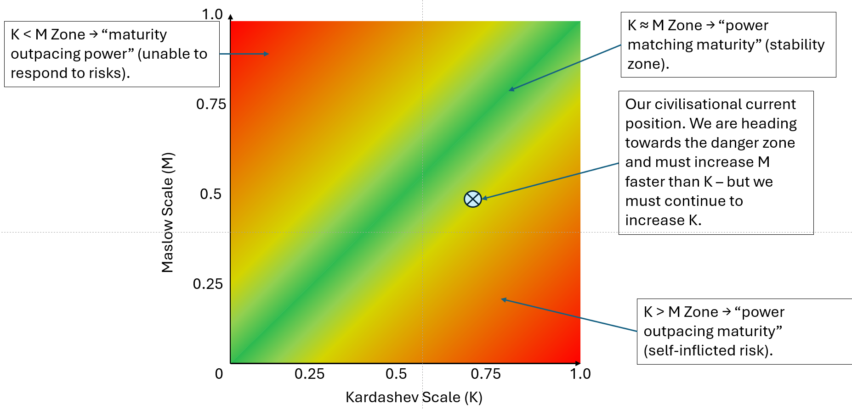

Stored in: GitHub CivOS repository
Includes:
- K axis
- M axis
- Δ mismatch
- Stability regions
- Humanity’s approximate position

5. Dependencies
This deliverable depends on:
- BOSCARD
- L0-D1 — Architecture Blueprint
- L0-D3 — Scope & Boundaries
- L0-D7 — Assumptions & Dependencies

6. Interfaces
Upstream of:
- L0-D4 — Anti-Capture Doctrine
- L0-D5 — Governance Principles
- L0-D6 — Risk Register
- L0-D8 — Success Criteria
- L0-D9 — L1 Roadmap
- All L1 standards
- All L2 Families

7. Risks & Constraints
- Model may be misinterpreted as predictive
- Numerical values may imply false precision
- Thresholds may be culturally biased
- M-axis oversimplifies complex sociopolitical dynamics
- Δ may behave non-linearly
- Lack of empirical calibration limits confidence
- Potential political misuse

8. Success Criteria
- K and M axes are clearly defined
- Mathematical expressions are unambiguous
- Δ mismatch is interpretable
- Thresholds are justified as provisional
- Epistemic limits are explicit
- Model supports architectural reasoning
- Diagram matches the written model

9. Version History
Version | Date | Author | Notes
0.1 | 05-06-2026 | Steve | Initial draft
0.2 | 05-06-2026 | Steve | Added epistemic limits, revised thresholds, clarified model status
0.3 | 06-06-2026 | Steve | Added scoring rubric for M

10. Future Work and Validation Path
To improve rigour:
- Analyse historical civilisational stress events
- Develop measurable indicators for each M-dimension
- Perform cross-cultural calibration
- Explore non-linear Δ behaviour
- Conduct simulation studies
- Integrate ecological and technological forecasting
This ensures the model evolves with evidence.

